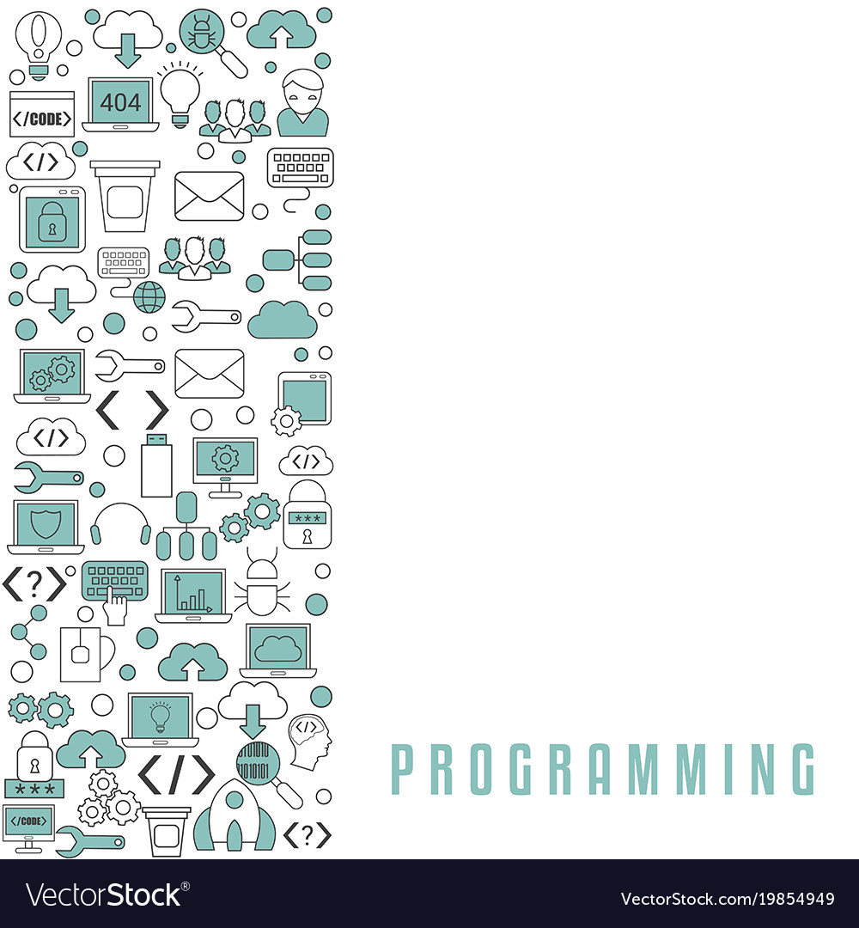

**ID:**

**Algorithmic Thinker’s Workbook**